# Descendants of Cornelis Aertsen Van Schaick, Volume II

# THE VAN SCHAICK FAMILIES IN THE NETHERLANDS

In an effort to develop additional information concerning the Van Schaicks in The Netherlands the Compiler employed Mr. John E. Eekhoutte, of Bunik, Province of Utrecht, The Netherlands. In connection with his research, Mr. Eekhoutte located in the Archives of the Province of Utrecht a 14 page manuscript prepared by A. Buchel, a genealogist and historian, who lived in the 1575-1650 period.

The manuscript is a genealogy and history pertaining to many Van Schaycks (also spelling varients) for the period 1325 to 1650. If you substitute an 'y' the surname becomes Van Schaick. The Compiler was advised by a genealogist of the Central Bureau voor Genealogie at The Hague that the surname spelling Van Schaick, Van Schayck and Van Schaik were to a considerable extent interchangeable and one should not be too concerned if variences were found in the early time periods.

The manuscript includes drawings of the Van Schayck Coat of Arms which closely resemble the authenticated Coat of Arms in this volume. The writing and/or printing of the manuscript is called ancient Dutch and presents a considerable problem in translation to English. Two translators declined the assignment. Finally, Mr. Eekhoutte agreed to tackle the difficult task. The resulting translation was helpful through providing knowledge about these Dutch families, but it was not organized into a format which would make it meaningful to the reader of this volume. After considerable study of the data the Compiler concluded that it would be necessary for him to go to Holland and work with Mr. Eekhoutee in organizing the information and connecting the individuals or some of them with the family of Adriaen Cornelis Van Schaick of Westbroek, father of Cornelis Aertsen.

It is evident from the manuscript that the Van Schaycks of Utrecht Province were prominent citizens during this period. Several were Aldermen, Baliffs, and Burgers of the Province. The occupations and business of the persons listed in the manuscript include brewers, a lawyer and priest, a goldsmith, glass writer, several merchants, land owners, farmers and artisans.

THE VAN SCHAICK COAT OF ARMS

The authenticated Coat of Arms in this volume is comparable to the Coat of Arms used by Heynrick Jacobsz Van Schaick, Alderman of the Heerlijkheid Hagensteyn on 1 April 1554 for the authentication of a Charter issued by a three Judge Court in connection with the transfer to Peter Gerritsz of six Mergens of land (about 12 acres) situated in the Joffrouwen Haich, owned by the widow of Heylgen Frederics van Meerlo.

It appears from the investigation made by Mr. Eekhoutte, at the Compilers request, that a similar, but earlier Charter or Coat of Arms of the Van Schaycks is in the General Archives of The Netherlands at The Hague. It is dated 30 April 1490. However, it is in such poor physical condition that it cannot be removed for photographing. It was used by Willem van Schaick who received property from the Capitol of Oud Munster which is in 'De Weerde', the district in which Westbroek is situated.

Until about 1930 the Charter of 1 April 1554 was in the possession of Baron Heerema Von Zuydwijk at Schloss Surenburg near Munster, Germany. It was returned at that time to the General Archives at The Hague, together with other documents pertaining to the village of Hagensteyn in the Province of Utrecht. The ancestors of the Baron owned the lands of the village. There is no family relationship between Baron Heerema and the Van Schaycks. There was only an Administrative relationship between the Baron and his Sheriff and Alderman who were submitted to his authority. In turn the authority of the Baron was submitted to the feudal Lord, in this case, the Sovereigns of Burgundy. The three fleurs de lys in the Coat of Arms undoubtedly reflect subordination to the Sovereign.

The Coat of Arms or Blazons as they are called in The Netherlands were not considered an award, but were used to distinguish families when they sealed official documents. They were used instead of signatures. The Charter of 1 April 1554 has attached to it by ribbons the seals of each of the three members of the Court. The center seal is of Henrick Jacobsz Van Schayck, the one at the right is that of Jan Diericksoen and on the left that of Loef Alfersoen. The seals are made of black wax the center of each being a replica of the Blazon of each family. The seal of Henrick is 24 millimeters or approximately one inch in diameter and reflects the three fleurs de lys.

*This information is from Descendants of Cornelis Aertsen Van Schaick, Vol II, pp. 10-12.*

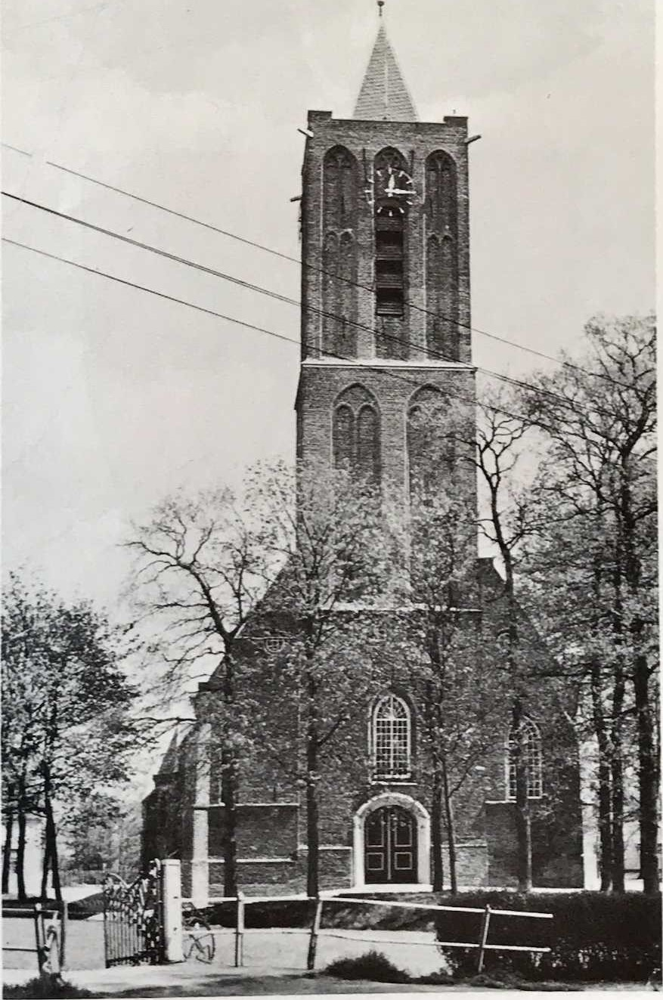

Westbroek Dutch Reformed Church Completed 1481

